Financial Partnerships as a Pathway to Financial Inclusion
White Paper
Advancing Equity Through the Financial Inclusion and Resilience Movement (FIRM)

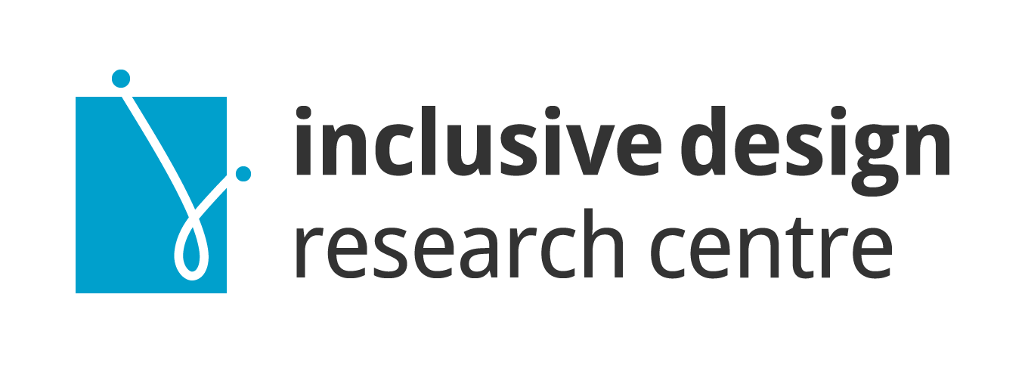

Prepared by
Inclusive Design Research Centre (IDRC)

Funded by
Employment and Social Development Canada (ESDC)

Date
October 2025

Contents
Executive Summary 3
Introduction 4
Barriers to Financial Inclusion 4
Barriers faced by individuals 4
Barriers faced by community organizations 5
Barriers faced by financial institutions 6
Building Inclusive Financial Systems: The FIRM Framework 6
From insight to action 7
Digital Shared Services Hub: Strengthening Community Organizations 8
Online Knowledge Hub: Facilitating Institutional Collaboration 10
Community-Led Governance: Shifting Power and Accountability 11
Community of Practice: Connecting and strengthening the ecosystem 13
Conclusion and Call to Action 14

Executive Summary
This white paper builds on Partnerships for Financial Inclusion, a multi-year initiative funded by Employment and Social Development Canada (ESDC) and led by the Inclusive Design Research Centre (IDRC). Through this project, we conducted an environmental scan of financial inclusion efforts and partnered with five grassroots, cross-disability organizations that support communities most excluded from the financial system—including people with disabilities, newcomers, low-income households, and others facing systemic barriers.
Our findings are clear: financial systems in Canada are not designed for everyone. Millions remain unbanked or underbanked—not by choice, but due to structural exclusion. In response, we co-developed practical tools, frameworks, and recommendations to help financial institutions create more inclusive services.
But inclusion requires more than resources. It demands a systemic shift in how financial systems engage with and support communities at the margins. That’s why we propose the Financial Inclusion and Resilience Movement (FIRM)—a community-led infrastructure designed to strengthen grassroots capacity, foster institutional collaboration, and create pathways for inclusive financial innovation.
FIRM includes four core components:
- A Digital Shared Services Hub to reduce operational barriers for community organizations by providing access to legal, bookkeeping, fundraising, and technology services.
- An Online Knowledge Hub to facilitate direct engagement between financial institutions and underserved communities through co-design, research, and accessibility consulting.
- Community-led Governance to ensure decision-making is grounded in lived experience and reflects community priorities.
- A Community of Practice (CoP) to support peer learning, collaborative research, and knowledge exchange across regions and sectors.
FIRM is scalable, sustainable, and grounded in equity. It builds power within communities while equipping institutions with the tools and relationships needed to serve all Canadians with diverse needs. This white paper outlines the rationale, structure, and strategies behind FIRM, and calls on financial institutions, funders, policymakers, and community leaders to join us in building a more inclusive and resilient financial future.

Introduction
In Canada, millions of people face daily barriers to accessing basic financial services. These barriers disproportionately affect people with disabilities, Deaf individuals, racialized immigrants, newcomers, single parents, and those without stable housing or government-issued identification. Financial exclusion is not a fringe issue, it is widespread, deeply systemic, and closely tied to broader patterns of inequality.
Inclusive financial systems are not just about access, they are about dignity, opportunity, and justice. Achieving financial inclusion requires addressing the complex, layered nature of exclusion across three interconnected levels:
- Individuals navigating financial instability and systemic barriers.
- Community organizations providing trusted support, often without adequate resources.
- Financial institutions shaping access to financial tools, yet frequently disconnected from those most in need.
This white paper explores these layers in depth and proposes a systemic response: the Financial Inclusion and Resilience Movement (FIRM). Developed through co-design with grassroots organizations and lived-experience communities, the FIRM offers a scalable model to bridge gaps, build capacity and foster inclusive financial ecosystems.
FIRM includes four core components:
- An online Knowledge Hub for institutional collaboration and accessibility consulting.
- A Community of Practice (CoP) for peer learning and shared innovation.
- Community-led Governance to ensure decision-making is grounded in lived experience.
- A digital Shared Services Hub to support grassroots organizations with operational infrastructure.

Barriers to Financial Inclusion
Financial exclusion manifests differently across the ecosystem, but its impacts are deeply interconnected. To build a truly inclusive financial system, we must understand the distinct challenges faced by individuals, community organizations, and financial institutions.

Barriers faced by individuals
People at the sharpest edges of financial exclusion, such as disabled and Deaf individuals, low-income households, and newcomers often navigate complex financial challenges alone. Many rely on informal support networks of family and friends. Some connect with grassroots organizations for help, but far too many fall through the cracks.
Each person’s experience is shaped by a unique combination of identity, environment, and circumstance. Because of this complexity, there is no one-size-fits-all description of the barriers individuals face. To better this complexity, our team collaborated with community members and organizations that work directly with populations most impacted by financial inequity.
Together, we developed two practical frameworks to help financial institutions and service providers assess where and how exclusion happens. These frameworks are described in detail in the Guidebook to Financial Inclusion, available on our website, https://financial-inclusion.inclusivedesign.ca.
- Hierarchy of Needs at Financial Institutions: Outlines progressive steps of financial access, from opening a basic account to engaging in long-term financial planning. It highlights where people are most likely to be excluded and why.
- Wheel of Financial Stability: Illustrates how external factors, such as cost of living, social aid policies, immigration status, stigma, and housing instability can affect an individual’s ability to achieve and maintain financial security.
Together, these frameworks provide a lens through which we can better understand the diversity of financial needs and the structural forces that prevent many from accessing services. They help us visualize where someone is situated within the current financial system and where the system is failing them.

Barriers faced by community organizations
Grassroots and community-based organizations are often the first –and sometimes only—line of support for people facing financial exclusion. These groups help individuals navigate complex systems, access government benefits, avoid predatory lending, recover identification, secure housing or food, and build basic financial stability. Their work fills gaps left by mainstream systems, and is often rooted in deep trust and community needs.
Despite their vital role, these organizations are chronically under-resourced. Many operate with minimal or no paid staff, rely heavily on volunteers, have no core or inconsistent funding and face significant operational and administrative challenges. Common barriers include:
- Limited capacity to manage finances, prepare audited reports, or meet legal obligations.
- Inconsistent access to funding due to complex grant processes and short timelines.
- Lack of infrastructure for technology, cybersecurity, and digital service delivery.
- Difficulty accessing affordable software, licenses, and professional services.
For example, a long-running, woman-led organization had to suspend services when most volunteers could no longer contribute due to age and disability. A community kitchen in a newcomer neighborhood missed a grant renewal deadline due to limited staffing and technical capacity.
These operational pressures divert energy away from core service delivery and place organizations at risk of burnout, liability, and closure. Without systemic support, even the most innovative and needed initiatives struggle to survive weakening the broader financial inclusion ecosystem.

Barriers faced by financial institutions
Financial institutions play a central role in shaping access to financial services, yet many struggle to build trust, relevance, and authentic relationships with underserved communities. Despite growing awareness of equity and inclusion as well as intentions to expand access, systemic barriers persist. Many institutions rely on outdated service models and data systems that prioritize the needs of the majority and limit meaningful engagement and innovation for those who are excluded.
Key challenges include:
- Rigid internal policies related to security, compliance, and confidentiality that constrain flexibility in approach or responsiveness to emerging needs.
- Siloed Innovation where inclusive service models, especially those designed with or by the communities they aim to support, are rarely prioritized or funded.
- Profitability concerns that deter investment in products or services tailored to low-income clients, people with disabilities, or those without traditional credit histories.
Additionally, many institutions lack the tools relationships and cultural competence needed for authentic engagement. Without trusted consultants from underserved communities, outreach efforts often fall short reinforcing mistrust and perpetuating exclusion.
These gaps contribute to a growing divide between financial service providers and the people who could most benefit from safe, affordable, and inclusive financial services. Bridging this divide requires new models of collaboration, accountability, and shared learning—principles that are central to the Financial Inclusion and Resilience Movement (FIRM).

Building Inclusive Financial Systems: The FIRM Framework
To address the interconnected challenges faced by individuals, community organizations and financial institutions, we propose a bold, scalable approach: the Financial Inclusion and Resilience Movement (FIRM).
FIRM is a community-led infrastructure designed to strengthen grassroots capacity, foster institutional collaboration and create pathways for inclusive financial innovation. It is built on principles of equity, accessibility and shared power and it supports all three layers of the financial inclusion ecosystem.
FIRM includes four core components:
- Digital Shared Services Hub: Offers operational support to grassroots organizations, including legal, bookkeeping, fundraising, and technology services.
- Online Knowledge Hub: Connects financial institutions with lived-experience communities through co-design, research, and accessibility consulting.
- Community-led Governance: Ensures decision-making is grounded in lived experience and reflects community priorities.
- Community of Practice (CoP): Facilitates peer learning, collaboration, and knowledge exchange across regions and sectors.
Figure 1: illustrates how FIRM’s four components work together to support a community-driven financial ecosystem—one that fosters innovation, builds capacity, and ensures that no one is left behind.

From insight to action
The Financial Inclusion and Resilience Movement (FIRM) is grounded in the insights gathered through co-design, environmental scans, and lived-experience collaboration. It responds directly to the challenges faced by individuals, community organizations, and financial institutions.
FIRM is not a theoretical model—it is a practical roadmap for building inclusive, community-driven financial systems. Its four core components are designed to:
- Address structural barriers to financial access.
- Strengthen grassroots capacity and leadership.
- Facilitate meaningful collaboration between institutions and communities.
- Create pathways for innovation, learning, and shared governance.
Each component includes:
- A challenge, grounded in lived and institutional experience
- A potential, outlining what is possible with the right support
- A strategy, detailing how FIRM can bring that vision to life
Together, these components form a scalable, equity-centred infrastructure that supports innovation, builds resilience, and ensures that no one is left behind.
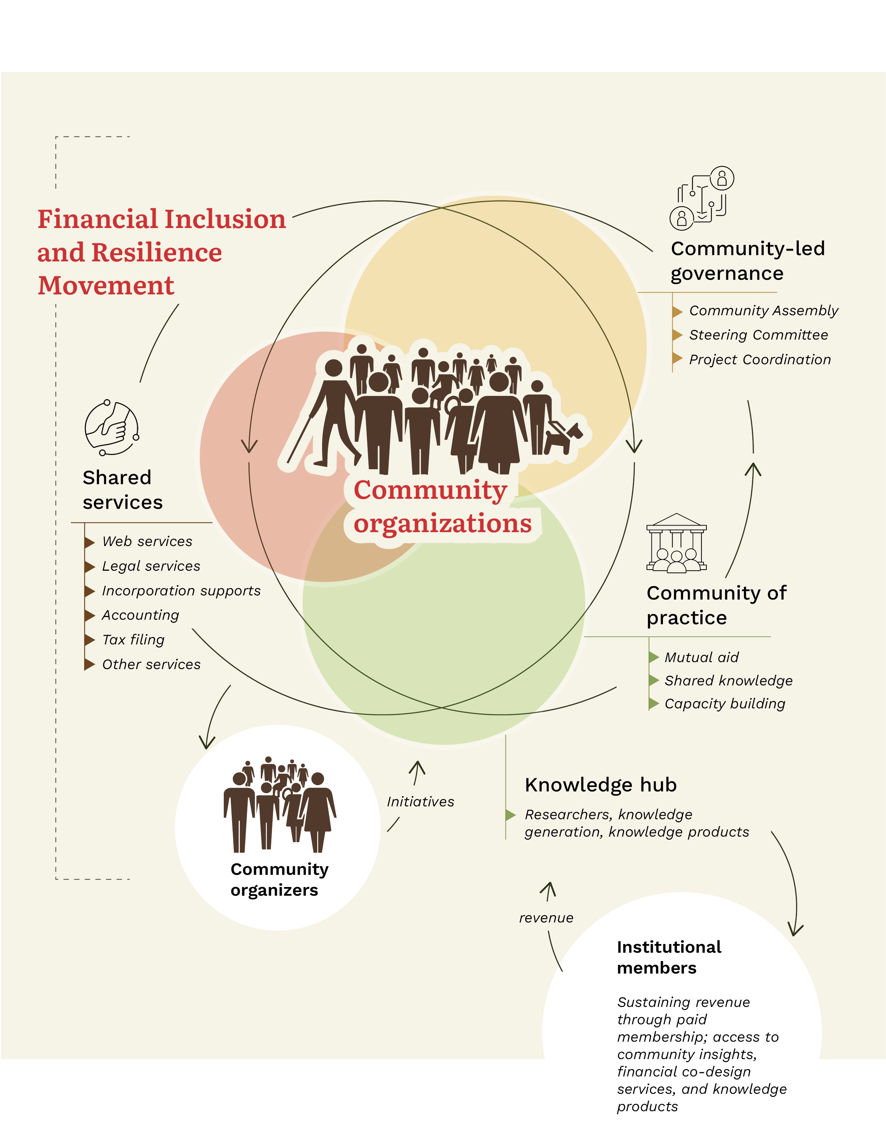
Figure 1: Financial Inclusion and Resilience Movement (FIRM)

Digital Shared Services Hub: Strengthening Community Organizations

Challenge:
Small and grassroots community organizations are often the first—and sometimes only—line of support for people experiencing financial exclusion. These groups help clients navigate complex systems, access social benefits, and build financial resilience. Yet, behind the scenes, they face significant operational and administrative barriers that threaten their sustainability.
Many operate with minimal or no paid staff, relying heavily on volunteers. Common challenges include:
- Managing finances and preparing audited reports,
- Navigating legal obligations, and incorporation processes
- Applying for grants and sustaining fundraising efforts
- Accessing affordable software, licenses and IT support.
Digital exclusion compounds these challenges. Software subscriptions are expensive, licensing structures are inaccessible, and many teams lack in-house tech support to manage cloud storage, data protection, or design tools. These operational pressures drain energy and resources away from the core mission that is serving community members in need.

Potential:
Imagine a robust shared services infrastructure that offers easy access to trusted, high-quality operational support. With such access, organizations can shift their focus from survival mode to strategy and service delivery.
For example:
- A grassroots women's ROSCA group could receive consistent accounting support and confidently run year-round financial literacy programs.
- A housing access initiative could submit polished, competitive grant applications written in collaboration with experienced fundraisers.
- A newcomer-led mutual aid network could access secure cloud storage and digital tools to manage client data safely and efficiently.

FIRM Strategy:
The Digital Shared Service Hub within FIRM will provide centralized operational support tailored to the needs of community-based organizations, cooperatives, and informal collectives.
Key services could include:
- Bookkeeping and accounting support: Monthly financial reporting, audit preparation, and CRA compliance.
- Legal and governance support: Incorporation, liability protection, contract review, and policy development.
- Grant writing and fundraising consulting: Identifying opportunities, crafting proposals, and building fundraising strategies.
- Shared licenses and subscriptions: Discounted or pooled access to tools like Zoom, Canva, Adobe Creative Suite, QuickBooks, and donor management platforms.
- IT and cybersecurity support: Secure databases, email systems, cloud storage, and training on data privacy and protection.
- Capacity building: Workshops and learning opportunities in nonprofit governance, budgeting, digital tools, and equity-informed evaluation.
These services will be free or offered at subsidized rates, supported through partnerships with legal clinics, accounting firms, IT cooperatives, and government programs. By removing structural burdens, the Shared Services Hub will strengthen the ecosystem of financial inclusion efforts across Canada and ensure that culturally grounded, disability-led organizations have the tools to thrive.

Online Knowledge Hub: Facilitating Institutional Collaboration

Challenge:
Financial institutions increasingly recognise the importance of equity and inclusion, but many struggle to engage meaningfully with the communities most excluded from their services. Despite good intentions, consultations often repeat the same questions, contributing to consultation fatigue—especially among disabled and Deaf communities. Feedback is frequently siloed or underutilised, and contributors are often not compensated equitably for their time and expertise.
Compounding these issues, institutions may lack the cultural competence, disability etiquette, and co-design capacity needed for respectful, reciprocal engagement. Without trusted relationships and community-led guidance, efforts to improve inclusion risk being transactional or performative.

Potential:
Imagine a model where financial institutions have ongoing access to lived-experience expertise and community knowledge through a curated, community-led hub. Rather than starting from scratch with each consultation, institutions could build on existing insights, engage trained co-designers, and develop services that are culturally informed, accessible, and effective.
Under this model, institutions would consult not out of compliance, but out of respect for community expertise. Contributors would be equitably compensated, and their input would directly shape the development of inclusive financial tools.

FIRM Strategy
The Online Knowledge Hub within FIRM will serve as a structured, sustainable platform that bridges the gap between community knowledge and institutional practice.
Key features include:
- Directory of community co-researchers and co-designers:
A database of trained contributors from cross-disability, racialized, newcomer, and low-income communities, available for design sprints, feedback sessions, and pilot collaborations.
- Living repository of insights and tools:
A continually updated library of community-generated content, such as, inclusive service frameworks, accessibility audit approaches and reports from past consultations.
- On-demand accessibility & usability consulting:
A responsive team of accessibility testers and inclusive design experts to review digital banking tools, fintech applications, in-branch systems, and customer-facing communications.
- Training for financial professionals:
Workshops and learning modules on disability etiquette, trauma-informed service, language justice, inclusive design led by community members with lived experiences of disability and exclusion.
- Compensation framework & ethical consultation guidelines:
Templates and ethical guidance for fair compensation, data rights, and respectful engagement when working with community consultants.
The Knowledge Hub will operate on a tiered membership model, with financial institutions subscribing to different access levels based on size, budget, and scope of engagement. Membership fees will sustain the hub and fund honoraria, mentorship programs, and training for community collaborators.
This model transforms episodic consultation into continuous partnership. It equips institutions with the tools to embed equity into their design and service models, while empowering communities to shape financial systems from the inside out.

Community-Led Governance: Shifting Power and Accountability

Challenge:
Community consultation is often treated as a checkbox rather than a meaningful transfer of power. Even when financial institutions seek input, the terms and scope of engagement are typically predetermined. As a result, feedback is filtered through institutional priorities, and programs often fail to reflect the values and realities of the communities they aim to serve.
Marginalised groups—especially disabled, Deaf, racialised, and newcomer communities—are frequently excluded from decision-making at systems and policy levels, where structural change could be enacted. Without governance roles, trust erodes and participation declines.

Potential:
A truly inclusive financial system must be shaped by the communities it impacts most. This means moving beyond one-off feedback loops to shared governance models where communities set priorities, direct resources, and hold institutions accountable.
Community-led governance ensure that financial inclusion strategies are:
- Grounded in lived experience
- Responsive to real-time community needs
- Equitably resourced
- Monitored and evaluated with public accountability

FIRM Strategy:
FIRM embeds community leadership at its core through a transparent, participatory governance model. While financial institutions and other stakeholders are invited to collaborate, decision-making authority remains with the communities most affected by financial exclusion.
Key features include:
- Steering committee:
A representative decision-making body composed of individuals from cross-disability and intersectional communities. This committee will guide FIRM’s priorities, partnerships, and evaluation metrics.
- Rotating leadership opportunities:
Time-limited roles for grassroots groups, youth organizers, and emerging leaders, to ensure distributed leadership and fresh perspectives.
- Community assembly with voting power:
An open body of community members that participates in annual budget setting, policy changes, and institutional membership approvals.
- Participatory budgeting & transparent reporting:
Public reporting on fund allocation, paired with participatory budgeting processes (e.g., community voting on pilot projects or priority services).
- Governance training & capacity building:
Accessible training for community members who want to take on governance roles, including topics about consensus-building, financial oversight and inclusive policy-making.
While FIRM does not require financial institutions to relinquish internal decision-making, it does require them to engage with and respect community governance structures when participating in FIRM-led initiatives. his model fosters mutual accountability, builds public trust, and ensures that financial inclusion is not just a service goal, but a structural norm

Community of Practice: Connecting and strengthening the ecosystem

Challenge:
Organizations working toward financial inclusion often operate in isolation, despite sharing common goals. Whether due to geography, limited capacity, or sectoral boundaries, many groups lack opportunities to learn from each other, build on tested ideas, or avoid repeating past mistakes.
This fragmentation leads to:
- Promising models failing to scale.
- Lessons learned not being shared constructively.
- Newcomers “reinventing” existing ideas or programs.
- Local innovations remaining local.
Without a mechanism for connection and shared learning, the collective ability to advocate for systemic change is weakened.

Potential:
Imagine a national, cross-sector Community of Practice where frontline organizations, financial institutions, policy advocates, and researchers:
- Exchange tools, frameworks, and real-world strategies
- Reflect on what has or hasn’t worked in their contexts
- Co-design new models together
- Build relationships that extend beyond projects
From an Indigenous-led credit union in the Prairies to a youth-led mutual aid network in Toronto, diverse groups could come together to share place-based, disability-informed, and culturally relevant strategies. When these ideas flow freely, the entire financial ecosystem becomes smarter, faster, and more inclusive.

FIRM Strategy:
FIRM will establish and maintain a Community of Practice focused on peer learning, mutual support, and knowledge co-creation.
Key features include:
- Monthly peer learning sessions:
Rotating presentations by community groups sharing case studies, innovations, and reflections. Sessions will be designed with access in mind, with services such as ASL interpretation, plain language summaries, and captioning provided through FIRM’s Shared Services Hub.).
- Cross-regional webinars & events:
Thematic sessions on emerging topics—such as ID barriers, accessible digital banking, or trauma-informed financial education—featuring diverse experiences from across Canada.
- Collaborative research hub:
Community-led research projects investigating shared challenges (e.g., how grant funding models disadvantage small orgs, or how banking tools could better serve newcomers), with findings published in accessible, open-source formats.
- An annual gathering:
A hybrid in-person/virtual summit for collective reflection, strategy-setting, and networking, organised by and for the community.
This Community of Practice will serve as the connective tissue that links grassroots expertise with systemic change. It will:
- Reduce duplication of effort
- Amplify underrepresented strategies
- Increase the visibility of regional and cultural insights
- Foster solidarity and movement-building across the country
Over time, this network can grow into a powerful force that is not just for learning, but for shaping public policy, funding strategies, and institutional design.

Conclusion and Call to Action
Financial exclusion in Canada is a systemic issue that demands a systemic response. The Financial Inclusion and Resilience Movement (FIRM) offers a community-led, scalable framework to address the structural barriers faced by individuals, grassroots organisations, and financial institutions.
By investing in shared services, collaborative knowledge-building, inclusive governance, and peer learning, FIRM strengthens the entire financial inclusion ecosystem. It centres lived experience, builds capacity, and fosters innovation — ensuring that financial systems serve all Canadians, not just the few.
We invite financial institutions, funders, policymakers, and community leaders to join us in advancing FIRM. Together, we can build a more just, resilient, and inclusive financial future.

